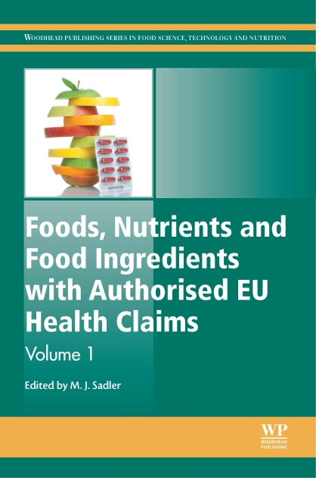

**FOOD SCIENCE, TECHNOLOGY & NUTRITION**

**Please contact your Elsevier Sales or Customer Service Representative**

**ISBN:** 978-0-85709-842-9

**PUB DATE:** April 2014

**LIST PRICE:** £180.00/€215.00/$295.00

**FORMAT:** Hardback

**PAGES:** c. 410

**AUDIENCE**  
Food, nutrients and food ingredients with authorised EU health claims is a standard reference for R&D managers and technical managers in the food, and beverage and dietary supplements industry, product development managers, health professionals and academic researchers in the field.

|  |
| --- |
| **Foods, Nutrients and Food Ingredients with Authorised EU Health Claims**  Edited by: ***Michele Sadler,* Director, Rank Nutrition Ltd, UK** |

**A key resource for R&D managers, product developers, and health professionals on permitted health claims foods and ingredients in the European Union**

A volume in the Woodhead Publishing Series in Food Science, Technology and Nutrition .

**KEY FEATURES**

* Provides a comprehensive overview of foods and food substances that have achieved approved health claims in Europe under Regulation EC 1924/2006
* Covers properties and applications of each ingredient, as well as evidence for the health claim and how it benefits consumers
* Outlines the importance of each claim in product development and marketing and regulatory issues such as conditions of use

**DESCRIPTION**

*Foods, Nutrients and Food Ingredients with Authorised EU Health Claims* provides an overview of how health claims are regulated in the European Union, as well as detailed scientific and regulatory information about permitted health claims for particular types of foods and ingredients.   
  
Part one provides a background to the regulation of health claims in Europe. Part two focuses on authorised disease risk reduction claims, claims relating to children’s development, and health and proprietary claims. Part three sets out ingredients with permitted “general function” claims, including choline, creatine, sweeteners, dietary lactase supplements, and polyphenols in olive oil. Part four outlines foods and nutrients with permitted health claims, with chapters on vitamins and minerals, proteins, meat, fish, water, and the replacement of saturated fats.   
  
*Foods, Nutrients and Food Ingredients with Authorised EU Health Claims* is the go-to resource for R&D managers and technical managers in the food, and beverage and dietary supplements industry, product development managers, health professionals and academic researchers in the field.



**FOOD SCIENCE, TECHNOLOGY & NUTRITION**

**Please contact your Elsevier Sales or Customer Service Representative**

|  |
| --- |
| **Foods, Nutrients and Food Ingredients with Authorised EU Health Claims**  Edited by: ***Michele Sadler,* Director, Rank Nutrition Ltd, UK** |

**Table of Contents**

**Part 1 Regulatory background**

The regulation of health claims in Europe.

**Part 2 Authorised disease risk reduction claims, children’s development and health claims, and proprietary claims**

Authorised EU health claims for barley and oat beta-glucans

Authorised EU health claims for xylitol and sugar-free chewing gum

Authorised children’s development and health claims in the EU

Authorised EU health claims for water-soluble tomato concentrate

**Part 3 Ingredients with permitted ‘general function’ claims**

Authorised EU health claims for choline

Authorised EU health claims for creatine

Authorised EU health claims for intense sweeteners and sugar replacers

Authorised EU health claims related to the management of lactose intolerance: Reduced lactose content, dietary lactase supplements, and live yoghurt cultures

Authorised EU health claims for polyphenols in olive oil; Resistant starch and post-prandial glycaemic responses

**Part 4 Foods and nutrients with permitted health claims**

Authorised EU health claims for betaine

Authorised EU health claims for vitamins and minerals

Authorised EU health claims for the replacement of saturated fats

Authorised EU health claims for proteins, meat and fish

Authorised EU health claim for walnuts

Authorised EU health claims for carbohydrate-electrolyte solutions

Authorised EU health claims for water