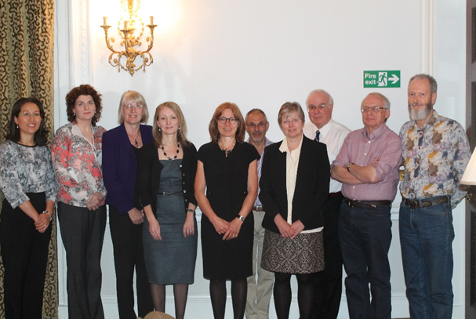

From left to right, Dr Sunhea Choi, Dr Alice Lucey, Dr Marilyn Glenville, Sara Stanner, Dr Michele Sadler, Professor Martin Wiseman, Dr Victoria J Burley, Professor Peter Aggett, Dr Ian Johnson and Professor Brian Ratcliffe.

At RSM Chandos House, London 22nd April 2015

